POLYTECHNIC OF NAMIBIA

SCHOOL OF NATURAL RESOURCES
DEPARTMENT OF AGRICULTURE
BACHELOR OF AGRICULTURE
Project Report, 2015 On:
The Influence of Goat Manure Application on Kale (Brassica oleracea) Yield and Soil Fertility in Henties Bay.


STUDENT NAME : MS JOSEFINA MUHAMA
STUDENT NUMBER : 213078228
TUTOR’S NAME : Dr. HIL MA RANTILLA AMWELE
MENTOR’S NAME : MR. EDGA MOWA
DUTY STATION : SAM NUJOMA MARINE AND COASTAL RESOURCES RESEARCH CENTER (SANUMARC), 2015

CONTENTS
- Introduction………………………………………………………………..1
- Objectives………………………………………………………………….4
- Null hypothesis…………………………………………………………….4
- Materials and methods……………………………………………………..5
- Data collection and statistical analysis……………………………………8
- Results and discussions……………………………………………………9
- Conclusions and recommendations……………………………………….12
- References…………………………………………………………………13

- Introduction
It has long been recognized that manure application is one of the most effective ways of improving soil fertility and crop production in tropical African conditions (Dennison, 1961). Organic manures are able to enhance efficiency and reduce the need for chemical fertilizers, to improve the soil fertility and soil health. Goat manure has been used as a fertilizer to enrich the soil with nutrients to produce vegetables commonly in African countries such as Kenya, Nigeria, Namibia etc.. Goat manure is considered a valuable nutrient source when applied to soil at rates commensurate with good agronomic practices (S. Roy and Md. A. Kashem, 2014). The application of correct amounts of fertilizers requires special management practices, which are not yet fully understood with respect to optimize plant growth on coastal soils. Some of the most severe problems in soil fertility occur in arid and semi-arid regions of the world where there is insufficient vegetation to die and decompose into organic matter. Besides these regions, poor soil fertility also affects agriculture in coastal regions and areas affected by few vegetation cover. According to Phipps (2014) goat manure can create an optimal growing condition for plants. He further emphasized on the advantages of using goat manure such as that it can be composted and used as mulch; it helps gardeners produce healthier plants and crop yields and add nutrients in the soils as well as promoting plant growth and increase crop yield without the use of harmful chemicals. Studies have showed that goat manure has been used as a fertilizer to enrich the soil with nutrients in order to produce vegetables. Kale is one of the vegetable that has been produced with goat manure in most parts of Africa. Kale is a lesser known, good-natured Brassica family, that tolerates less than perfect soil and weather conditions and becomes sweeter with frost (Monica van Wensveen, 2009). She further added that Kale prefers cool temperatures, and should be planted in February-March for winter harvest. In Namibia the optimum application of fertilizer continues to be a challenge to farmers because they do not have the knowledge of the optimum amount they should apply in their fields. This research as it is some of the few to be done in Namibia will help to determine the correct application rate of goat manure on Kale along the Namibian coastal desert (Henties bay) for improvement of soil fertility.
- OBJECTIVES
- Determine the optimum application rate of goat manure on coastal soils for vegetable production.
- Evaluate the effect of goat manure to kale within foliage and stem growth.
- NULL HYPOTHESIS
- H0 = There is no significant difference in Kale growth and yield between the control and the treatment.

- MATERIALS AND METHODS
Area site
The Research study took place at Sam Nujoma Marine & Coastal Resources Research Centre (SANUMARC), University of Namibia Henties Bay Campus in the green house. The Centre is located on a 100ha site to the north of Henties Bay, Erongo region on dunes overlooking the ocean and the Omaruru Riverbed. The center’s mission is to undertake research in Namibia to promote sustainable development and utilization of marine and coastal resources. The average rainfall is less than 20 mm per year, falls predominantly in the late summer. Average temperatures are mild throughout the year due to the influence of the cold Atlantic water (averaging 13 – 18 °C) which keeps the air above the sea cool and allows formation of fog which also helps to prevent day temperatures from rising high vegetation type is central desert.
Cultural methods
The soil was collected from Olive tree site at SANUMARC. Planting was done in planting bags in the greenhouse. Sowing of seeds was done in trays to a depth of 2 cm where 3-4 seeds were planted. Two weeks after germination, seedlings were ready to be transplanted; they were transplanted into planting bags as growth beds. The soil was weighed with a scale, micro T7E before and after drying using an incubator series 2000. The soil was dried for 24 hours at a temperature of 80˚C. Watering was done according to the water holding capacity. Water holding capacity was calculated using the following formula:
Water holding capacity = Mass of soil when saturated / Mass of dry soil * 100
Treatment and design
The experiment comprised of three treatments and the control of each treatment was replicated 4 times. The randomized complete block design was used whereby the green house walls were the blocking factor.
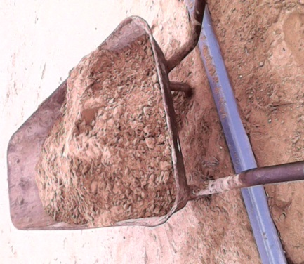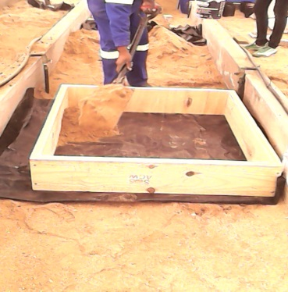
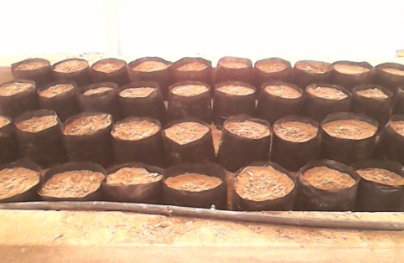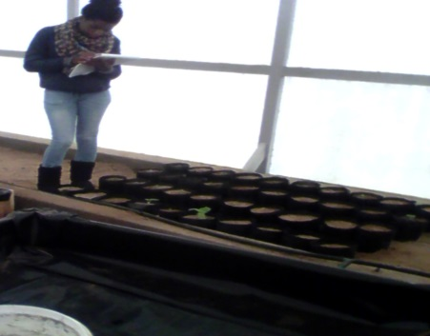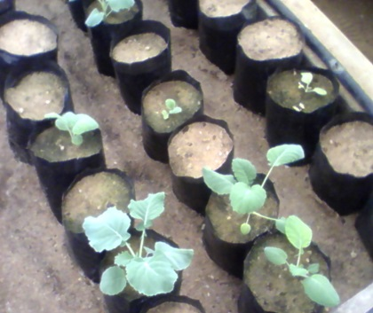
Collection of soil was done; the soil was then mixed with manure according to its ratio in a wooden square box of 1m2 at a depth of 15 cm. The manure applied to the soil was measured using a scale, (micro T7E). And then, the mixed soil was put in the planting growth bags were seedlings transplanted.

Formulation of ratios
Table 1
Elements |  | Olive tree site (ppm) |  | General soil requirement for vegetables production(ppm)
N |  | 10 000 |  | 26-50
P |  | 1.42 |  | 11-20
K |  | 128 |  | 30-419
Ca |  | 2094 |  | 460-749
Na |  | 4570 |  | 400-999
Mg |  | 226 |  | 100-150
CEC |  | 17.94 |  | 15-30
Chemical composition of goat manure (%)
N |  | 1.37
P |  | 0.84
K |  | 0.30
Ca |  | 1.00
Na |  | 0.08
Mg |  | 0.48
Table 1 shows the composition of elements in Olive tree site where the soil for the study was collected and the general soil requirements for vegetable production, regardless of where they are grown or the type of soil. It also shows the element composition of goat manure in general, depending of what the animal fed on or its age.

Table 2

 | Treatments |  | Manure application ratio (t/ha)
 | T1 |  | 20:1
 | T2 |  | 30:1 (Optimum)
 | T3 |  | 40:1
 | Control |  | No manure

Table 3 shows the treatments and their manure application ratio as well as the control. The formulation of the ratio was done by comparing what other studies have done by looking at the amount of manure applied and the type of soil. It was then compared to Olive tree site and to the general soil requirements for vegetable production.
Measurements
The parameters that were measured are: Leaf length, leaf number per plant. The leaf length was measured with a ruler; leaf number per plant was counted. The parameters (leaf number and leaf length), was recorded once a week every Monday.
- DATA COLLECTION AND STATISTICAL ANALYSIS
One-way ANOVA statistical test was used to determine whether there are any significant differences between the treatments and control.

- RESULTS AND DISCUSSION

  - Data analysis report for the parameter leaf number
Anova: Single Factor
 | SUMMARY
 | Groups |  | Count |  | Sum |  | Average |  | Variance
 | Control |  | 440 |  | 1204 |  | 2.736364 |  | 2.463367
 | T1  T2 |  | 440  440 |  | 1221  666 |  | 2.775  1.513636 |  | 2.903702  2.541955
 | T3 |  | 440 |  | 485 |  | 1.102273 |  | 1.754892
ANOVA
Source of Variation |  |  |  | SS |  | df |  | MS |  | F |  | P-value |  | F crit
Between Groups |  |  |  | 893.165 |  | 3 |  | 297.7217 |  | 131.3596 |  | 4.73E-76 |  | 2.610478
Within Groups |  |  |  | 3617.275 |  | 1596 |  | 2.266463
Total |  |  |  | 4510.44 |  | 1599
131.35966
2.610478
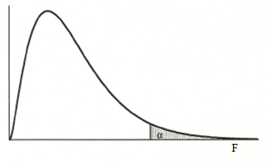

Since the F value (131.3596) lies within the rejection region, we reject H0. Therefore we are 95% confident that there is a significant difference between the treatments.

  - Data analysis for the parameter leaf length

Anova: Single Factor
SUMMARY
Groups | Count | Sum | Average | Variance
T1 | 406 | 490.8625 | 1.209021 | 1.107552
T2 | 406 | 214.07 | 0.527266 | 0.57448
T3 | 406 | 144.2575 | 0.355314 | 0.202165
Control | 406 | 643.5675 | 1.585142 | 1.725942
ANOVA
Source of Variation | SS | df | MS | F | P-value | F crit
Between Groups | 405.6159 | 3 | 135.2053 | 149.8062 | 1.11E-85 | 2.610395
Within Groups | 1462.106 | 1620 | 0.902535
Total | 1867.722 | 1623

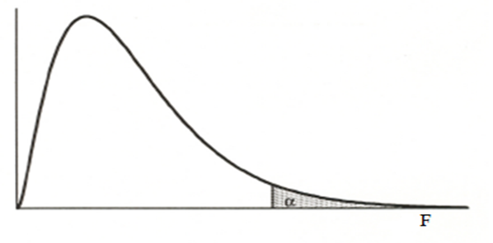
149.806
2.6103992

Since the F value (149.806) lies within the rejection region, we reject H0. Therefore we are 95% confident that there is a significant difference between the treatments.

- CONCLUSIONS AND RECOMMENDATIONS
The study concluded that; T1 whereby 20t/ha of manure was applied did well compared to the others, therefore T1 can be advised to be used by farmers as well as community of Henties bay. I recommend that further research on soil fertility should be done, and this time, weight and biomass of the yield should be one of the parameters to be looked at.

- REFERENCES
- Kihanda, F. M. et al, (1995). The Influence of Goat Manure Application on Crop Yield and Soil Nitrate Variations in Semi-Arid Eastern Kenya.
- Odedina J, (2011). Effect of Types of Manure on Growth and Yield of Cassava (Manihot esculenta, Crantz).
- Dennison, (1961). Effect of goat manure, and combination of their reduced levels on maize growth and soil chemical.
- Tiamiyu R.A, Ahmed H.G and Muhammad A.S.(2012). Effect of sources of organic manure on growth and yield of okra.
- Brown, M.E. (1957). Experimental studies on growth .In: Physiology of fish’s vol1 (2) .pp361-400, New York: Academic press. http://fishphysiology.org/wp-content/uploads/2014/02/Jun1.pdf.

