TITLE: Assessment of Community Structure of Mycorrhizal Fungi Associated with Rice Varieties in Five States of Nigeria
*Babalola O.A.¹ Olubode A.A.¹ Atayese M.O.² Dare M.O.^{1,3}, Adejuyigbe C.O.¹ and Okeleye K.A²
*babalolaoa@funnab.edu.ng, bimbola05@yahoo.com
1Department of Soil Science and Land Management, Federal University of Agriculture, Abeokuta, Nigeria.
2Department of Plant Physiology and Crop Production, Federal University of Agriculture, Abeokuta, Nigeria.
3Department of Biological Sciences, Faculty of Agriculture, Science and Technology, North-West University, Mafikeng Campus, Mmabatho, South Africa.
ABSTRACT
The symbiotic association between Arbuscular Mycorrhizal Fungi (AMF) and the roots of plants is widespread in natural environment and it is highly beneficial to plants, increasing their nutrient uptake and tolerance to disease and drought. This symbiotic association was surveyed in rice grown on farmers’ fields in five Nigerian states (Osun, Oyo, Ogun, Ekiti and Niger).The AMF spores were isolated and identified using information from Network for Vesicular Arbuscular Mycorrhiza (INVAM), and percent root colonization was evaluated by spreading stained roots evenly in grid plates, and observing scanned vertical and horizontal lines under dissecting microscope. The thirteen rice varieties observed on farmers’ fields had varying degrees of association with AMF. Rhizosphere soils of Ofada, NERICA 1 and ITA 150 had significant spore counts of 227, 177 and 144 per 20 g soil respectively while roots of Ofada, UORG, NERICA 8, NERICA 1 and UN111 had significant colonizations of 70.4 %, 67.9 %, 65.3 %, 52.1 % and 49.8 % respectively. Four genera, (Gigaspora, Glomus, Scutellospora and Acaulospora) and thirteen species were encountered in the five states. Spores of Glomus mossaea, G intraradices and Gigaspora sp. were isolated from all the five states. Relative abundance of spores varied among the states and also among the species, spores of Glomus species were high in all the five states while spores of Acaulospora, Gigaspora and Scutellospora species were significant only in Ogun state. Thus total spore abundance, species evenness and H’ index were significantly higher in Ogun state than other states, H’ index was highest in Ogun state (2.2), followed by in Osun state (1.9) and lowest in Oyo state (0.7). It was concluded that the diversity and population of AMF was enhanced on rice grown in Ogun state as a result of higher number of varieties planted in that state.
INTRODUCTION
Rice (Oryza sativa L) is cultivated widely in Nigeria under upland and lowland conditions. It has gradually become a staple food consumed by most households on daily basis. Presently, a substantial part of rice consumed in Nigeria is imported even though the climatic and soil conditions in many parts of the country favour rice cultivation. Because of lower price, imported rice enjoins more popularity than locally cultivated rice, in spite of the higher nutritional quality of the latter. The cost of production is higher because of high costs of inputs and inconsistencies in rainfall pattern. Rice plants readily form mycorrhizal associations under upland conditions, but under submerged conditions infection is rare due to the anoxic environment (Illag et al., 1987). Research reports have revealed that inoculation of AMF in high and low fertility soil promote nutrient acquisition of rice and increase rice yield (Gupta and Ali, 1993; Secilia and Bagyaraj, 1992). In order to encourage and improve rice cultivation in Nigeria it is necessary to explore biological interactions in reducing cost of production. Efficient use of AMF interaction in rice production has the potential to reduce the use of inputs such as fertilizers and pesticides as well as improve drought tolerance in upland rice. The aim of this study is to isolate, identify and select AMF associated with rice varieties in some rice growing states across Nigeria.
MATERIALS AND METHODS
A survey of farmer’s fields was carried out in five states (Ogun, Oyo, Ekiti, Osun and Niger) of Nigeria. Rhizosphere (root and the adhering soil) samples of rice plants were taken from five farmer’s fields in five locations of each state. In the laboratory, the roots were washed in several changes of water and preserved in 50 % alcohol. The soil samples were suspended in 500ml of water stirred thoroughly to bring spore to suspension and allowed to stand for 30 seconds. Thereafter the suspension was wet sieved in nested sieves in a manner modified from Gerdeman and Nocholson, (1963). The 710 and 45 µm were subjected to centrifugation in a 4 % sucrose solution to separate the spores (Jenkin, 1964) and the spores were counted under 80 magnification. Spores were identified according to current taxonomic criteria (Schenck and Perez, 1990) and using information from international network for versicular arbuscular mycorrhiza (INVAM). Shnnon-Weiner biodiversity index was used to evaluate the AMF diversity. This appears as the product of the two main components of diversity: evenness and richness. Species richness and density were analysed using an independent t-test.
H′ = −∑_{i=1} ^{k} pi x in pi,
Where: k is the total species number of one site, and pi is the relative abundance of AM fungus species of the site.
The preserved roots were cleared in 10 % KOH at 80ºC for 30 minutes, followed by rinses with 1 % KOH, thereafter the roots were immersed in a staining solution of lactic acid, glycerol and water (1:1:1) and 1 % each of tryphan blue and methylene blue at 80ºC for 1.5 hours. The stained roots were then washed in tap water for 30 minutes at room temperature to destain (McGonigle et al., 1990). Colonization rate was determined by spreading the roots evenly in grid plate and under a dissecting microscope. Percent colonization was calculated as:
% colonization = (Total number of intersections with mycorrhizal infected root/Total number of intersections between roots and the grid line) X 100.
The data were subjected to analysis of variance (SAS, 1990) treatment means were separated at 5 % probability by least significant difference.
RESULT
The number of rice varieties observed in the five locations surveyed in each state were; one in Niger state, two each in Osun and Oyo states and seven each in Ekiti and Ogun states (Table 1).
Table 1: Rice varieties grown in locations surveyed in Osun, Oyo, Ekiti, Ogun and Niger states of Nigeria
States | Varieties
Osun | ITA 150
 | ITA 157
Oyo | WITA 4
 | NERICA 1
Ekiti | Igbimo rice
 | UORG311
 | UDRW111
 | UDM4A11
 | NERICA 1
 | NERICA 2
 | NERICA 8
Ogun | Ofada
 | NERICA 1
 | NERICA 8
 | UDM4A11
 | UORG311
UN111
UDRW111
Niger | FARO

Thirteen species of AMF were encountered in all the locations across the five states, four of them (Glomus intraradices, Glomus mosseae Glomus etunicatum and Gigaspora sp) occurred in all the locations (Table 2). The other nine were observed only in some of the states. Two species of Glomus were encountered in only Ogun state.
Table 2: The AMF species isolated from farmers’ fields in Osun, Oyo, Ekiti, Ogun and Niger States of Nigeria.
Isolates | State
Isolates | Osun | Ekiti | Oyo | Ogun | Niger
Glomus intraradices | + | + | + | + | +
Glomus mosseae | + | + | + | + | +
Glomus etunicatum | + | + | + | + | +
Glomus claroideum | + | + | - | + | -
Glomus clarum | + | + | - | + | +
Glomus microaggregatum | + | - | - | + | -
Gigaspora sp. | + | + | + | + | +
Scutellospora sp. | + | + | - | + | -
Scutellospora pellucida | - | - | - | + | -
Accaulospora scorobiculata  Accaullospora sp.  Glomus sp.  Glomus sp. | -  +  -  - | +  -  -  - | -  -  -  - | +  +  +  + | +  -  -  -

The spores of Gigaspora sp, Glomus sp. and Glomus mosseae were significantly higher on farms in Ogun state than in the other states, however spores of Glomus interadices were similar on farms in Ekiti, Ogun and Oyo states but significantly lower in the other states (Fig.1). The abundance of these mycorrhizal species in Ogun state (also revealed in figure 2a) might be attributed to the preference of these mycorrhizal species for the rice varieties cultivated in this state. Species specificity of AMF is well known in many crops. Species evenness and diversity were significantly higher in Osun and Ogun states but least in Oyo state. Two varieties of rice were recorded on farmers’ fields in Osun and Oyo states, while seven were recorded in Ogun and Ekiti states, suggesting that varieties grown in Osun and Ekiti states probably have more affinity for AMF than those grown in the other states. The abundance of AMF spores and colonization rates vary among the varieties (Fig. 3). It is observed that Ofada and Nerica 8 had significantly higher colonization while spore abundance was significantly higher only in the rhizosphere of Ofada.

Figure 1: Spore abundance of Gigaspora sp (a), Glomus sp (b), Glomus mosseae (c), Glomus intraradices (d) across the five States.
Note: Bars with same letters are not significantly different as indicated by LSD p≤ 0.05

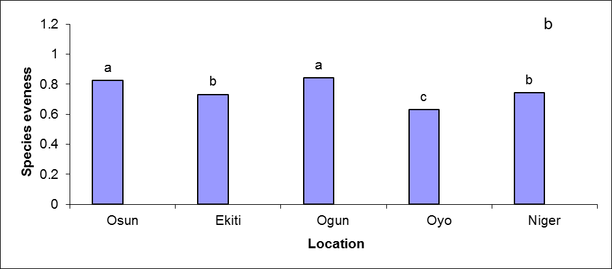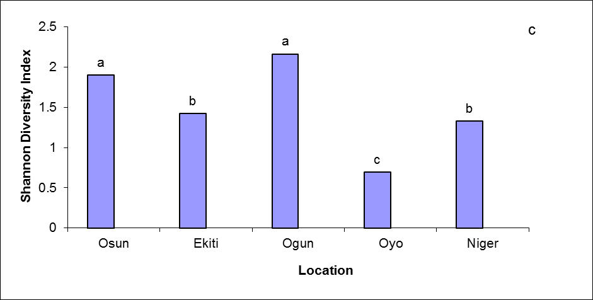
Figure 2: Total spore density (a), species evenness (b) and Diversity index (c) of AM fungi in Osun, Oyo, Ekiti, Ogun and Niger States of Nigeria.
Note: Bars with same letters are not significantly different as indicated by LSD p≤ 0.05

b
Figure 3: Effect of rice varieties on spore abundance (a) AMF colonization (b) in Ogun state of Nigeria. Bars with same letters are not significantly different as indicated by LSD p≤ 0.05

CONCLUSION
Thirteen AMF species were observed in the rhizosphere of rice in all the five states that were surveyed. Four of them were encountered across all the states, while nine were present in 1-4 states. Ogun state had the highest relative abundance, density, evenness and diversity of spores due to AMF preference for some of the rice varieties grown in that state. Further studies should explore the use of AMF inoculation to improve rice and drought tolerance in low input agriculture, particularly in Ogun state.
ACKNOWLEDGEMENT
The authors wish to acknowledge Agricultural Research Council of Nigeria for the sponsorship of this research. The authors are also grateful to Drs S.G Aderibigbe and C. Okonji for assistance in collection of soil and plant samples.

REFERENCES
Gerdemann J, Nicolson TH . 1963. Spores of mycorrhizal Endogone species extracted from soil by wet sieving and decanting. Trans. Br. Mycol. Soc. 46:235–244.
Gupter N, Ali SS 1993 VAM inoculation for wetland rice. Mycorrhiza news 5: 5-6
Illag LL, Rosales AM, Elazegui FA, Mew TW 1987. Changes in the populations on infective endomycorrhizal fungi in rice-basedcropping system. Plant and Soil 103: 67-73
McGonigle TP, Miller MH, Evans DG, Swan JA . 1990. A new method which gives an objective-measure of colonization of roots by vesicular arbuscular mycorrhizal fungi. New Phytol. 115:495–501.
Statistical Analysis Systems Institute 1990. SAS-STAT User’s Guide, Version 6, 4th Edn. Cary, NC, USA: SAS Institute
Schenck, N.C. and Perez, Y. 1990. Manual for the identification of VA mycorrhizal fungi 3rd Edition. Synergistic Publications, Gainesville. 1-286.
Secilia J, Bagyarej DJ 1992. Selection of efficient vesicular arbuscular mycorrhizal fungi for wetland rice (Oryza sativa L) Plants Biol. Fertil. Soil 13: 108-111

